**Docker image practiced screenshots**

Docker -v

Docker images

Images –help

Docker pull ubuntu

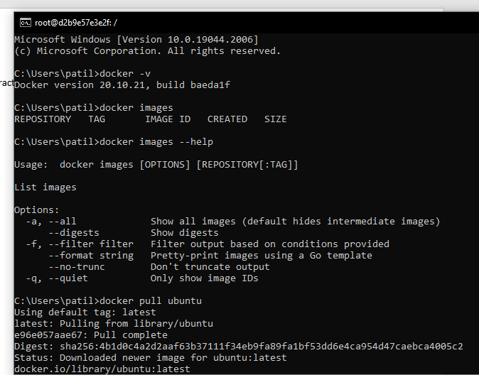

Docker images

Docker pull ubuntu:18.04 (for pulling specific tagged images)

Docker images -q (gives unique image Id)

Docker image -f “dangling=false”

(dangling means images which has not tag and which are not reffered by any container)

(-f for filteration)

Docker ps -a(ps means process status, in linux container is a like process)

Docker run –name mycontainer1 -it ubuntu bash (-it means interactive, bash for starting bash)

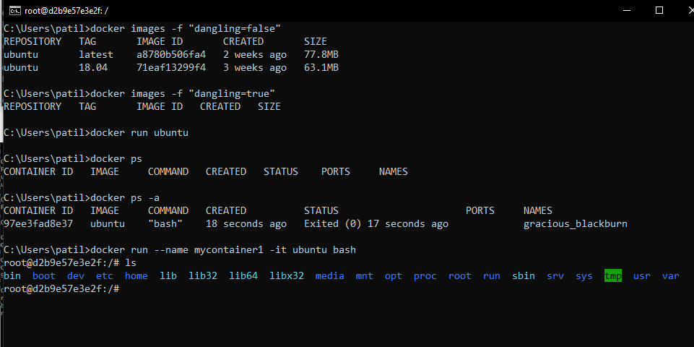

Here opened different command prompt, we can check here that 1 container is running (docker ps -a)

